PROJECT ON

**“RFID TOLL COLLECTION SYSTEM”**

BY

**MR.YOGESH SHALIGRAM**

**MR.YASH SATHE**

**MR.SWAPNIL SHINDE**

**MR.SHUBHAM SABALE**

UNDER THE GUIDANCE OF

**MRS. M S KULKARNI**

IN PARTIAL FULLMENT OF

DIPLOMA IN

**ELECTRONICS & TELECOMMUNICATION ENGINEERING**

DEPARTMENT OF

**ELECTRONICS & TELECOMMUNICATION**

**MAEER’S MIT POLYTECHNIC**

PUNE-411037

2016-2017

**ABSTRACT**

This project is related to RFID technology; this system uses a tag and the reader which collects information of vehicle passing through the toll plaza and will automatically debits the toll amount from the prepaid account of each vehicle, which in turn will reduce the traffic congestion and human errors. The vehicle owner has to register his vehicle with RFID tag, creating a rechargeable account.

A manual toll collection system is been used widely in India. But it is not very reliable. Manual toll collection system requires more processing time at the toll booth. This leads a very long queue at the toll booths and results in increase in pollution in that area. This also increases the traffic resulting in waste of fuel.

This project is designed to reduce these kinds of problems which are being faced by the travellers. This project will reduce the queue in front of the toll booths and pollution to some extent. This will also reduce the cost by less manpower requirement. This will also ensure correct toll collection & correct record keeping.

The project focuses on the collection of toll by RFID [Radio Frequency Identification]. The RFID card uses RFID tags for identification. Each card is given a unique number which is been saved in the system. This unique code is used by the RFID reader to get the information embedded in the tags.

In this system, each vehicle is given these tags. Every Toll collection booth will have a RFID system setup. The only thing driver needs to do is place his RFID tag on the reader. RFID reader will identify the unique code and will collect the amount of toll from the account the vehicle holds. After the toll is deducted, driver will receive a message for toll amount deducted and the remaining balance in his amount. This information will also be displayed on the screen at the toll booth gate.

After the toll is deducted, system will open the barrier and the vehicle can pass through.

**INDEX**

|  |  |  |
| --- | --- | --- |
| **CH.NO** | **CHAPTER** | **PAGE**  **NO.** |
| **1.** | **Introduction**   * 1. Motivation   2. Background   3. Need   4. Literature survey |  |
| **2.** | **Proposed Work**  2.1 Problem Definition  2.2 Features  2.3 Goals  2.4 Feasibility Study |  |
| **3.** | **Project Design**  3.1 Circuit Diagram  3.2 Hardware Description  3.3 Software Description  3.4 Algorithm  3.5 Flowchart |  |
| **4.** | **Schedule of work** |  |
| **5.** | **Implementation and Result**  5.1 Experimental Setup  5.2 Hardware Testing  5.3 Results with Screen Shots  5.4 Advantages  5.5 Disadvantages  5.6 Application  5.7 Costing |  |
| **6.** | **Conclusion and Future scope** |  |

**List of Figures**

**CHAPTER 1**

**Introduction**

* 1. **Motivation-**

This paper is based on RFID Toll Collection System. This system is based on Radio Frequency Identification technology which uses RFID Tag and RFID Reader for identification. The RF sensor in the system detects the approach of the incoming vehicle. The driver has to place the tag on the reader and toll deduction takes place through a prepaid card assigned to the concerned RFID tag that belongs to the owners’ account. This makes tollgate transaction more convenient for the public use.

The basic advantages of the system are travelling time is decreased, congestion free network, less emissions in toll area and no infrastructure cost is required.

The main idea behind implementing RFID BASED TOLL COLLECTION SYSTEM is to automate the toll collection process their by reducing the long queues at toll booths using the RFID tags owned by car owner.

* 1. **Background-**

Manual toll collection system is been used widely in India, but it is not very reliable. Manual toll collection system requires more time to collect the toll. This leads a very long queue on the toll booths and results in increase in pollution in that area. This also increases the traffic.

This system is designed to reduce these kinds of problems which are being faced by the travellers. It will also reduce the man power and the queue in front of the toll booths and pollution at some instance.

This system focuses on the collection of toll by RFID [Radio Frequency Identification]. The RFID card uses RFID tags for identification. Each card is given a unique number which is been saved in the system. This unique code is used by the RFID reader to get the information embedded in the tags.

In this system, each car is given these tags. Every Toll collection booth will have a RFID system setup. The only thing driver needs to do is place his RFID tag on the reader. RFID reader will identify the unique code and will deduct the amount of estimated toll from the account the driver holds. After the toll is deducted, driver will receive a message saying about the toll amount deducted and the remaining balance in his amount. This information will also be displayed on the screen provided in the system itself.

After the toll is deducted, system gives the instruction to the motor which opens the barrier and the driver can leave for the remaining journey.

This project will help in “SMART CITY” project laded by our Prime Minister Hon. Narendra Modi.

**1.3Need-**

As we know that manual toll collection system is not reliable and as compared to RFID toll collection system, Manual system has many disadvantages. As manual system is used widely, there are queue are formed in front of the toll booth and due to this time required to pay the toll is increased resulting in pollution in that area. This system also supports Digital payment so more transparency is maintained.

This system is designed to reduce the time required to pay the toll.

* 1. **Literature Survey-**

William Vickrey, the Nobel Economics prize winner, in 1959, was the first who proposed electronic toll system for Washington Metropolitan Area. Free flow tolling with fixed transponders undersides of vehicles and the readers were located under the highway surfaces (1960s and 1970s). This system was first introduced in Bergen (1986). World’s first use of completely unaided full speed electronic toll system was introduced by Trondheim (1991). Norway has electronic fee collection (EFC). The United States was the first to used ETC system in several states. In California, Texas, Florida, vehicles can travel at full speed through electronic lanes.

In 1959, Nobel Economics Prize winner William Vickrey was the first to propose a system of electronic tolling for the Washington Metropolitan Area. He proposed that each car would be equipped with a transponder. “The transponder’s personalised signal would be picked up when the car passed through an intersection, and then relayed to a central computer which would calculate the charge according to the intersection and the time of day and add it to the car’s bill”  Electronic toll collection has facilitated the concession to the private sector of the construction and operation of urban freeways, as well as made feasible the improvement and the practical implementation of road congestion pricing schemes in a limited number of urban areas to restrict auto travel in the most congested areas.

In the 1960s and 1970s, free flow tolling was tested with fixed transponders at the undersides of the vehicles and readers, which were located under the surface of the highway.

Norway has been the world's pioneer in the widespread implementation of this technology. ETC was first introduced in Bergen, in 1986, operating together with traditional tollbooths. In 1991, Trondheim introduced the world's first use of completely unaided full-speed electronic tolling. Norway now has 25 toll roads operating with electronic fee collection (EFC), as the Norwegian technology is called AutoPASS. In 1995, Portugal became the first country to apply a single, universal system to all tolls in the country, the Via Verde, which can also be used in parking lots and gas stations. The United States is another country with widespread use of ETC in several states, though many U.S. toll roads maintain the option of manual collection.

**Block Diagram**

RFID Tag

Display

RFID Tag

**MICROCONTROLLER**

Power Supply

RFID Reader

RFID Tag

Buzzer

**MICROCONTROLLER**

Power Supply

Motor

GSM Module

Display

RFID Reader

**2.2 Features-**

* Man power is reduced.
* We get a message of toll amount and remaining balance in the account.
* Queue in front of toll booths is reduced.
* Pollution gets decreased.
* Toll information is displayed on the screen.
* Fuel consumed is less.
* Traffic gets reduced.
* Requires less time to pay the toll.
* Transparency of Toll Transactions.
* Reduces Revenue Leakages.

**2.4 Feasibility Study**

Suppose a manual toll collection system takes around 20 seconds per car to collect the toll, if there are about 500 cars crosses the toll plaza,

This takes 20*500 i.e. about **167 minutes** for just 500 cars.

But if the same number of vehicles crosses the toll plaza, this system will only take 5 seconds,

This takes 5*500 i.e. about **50 minutes**

So, there is a great difference in the time required to collect the toll between the manual and RFID toll collection system. This reduces the pollution as there less queue in front of toll plaza

**3.4 Algorithm**

When a vehicle will enter in the toll area the IR sensor will get activated. First the driver has to place the RFID tag in front of the RFID reader. The RFID reader detects the unique number assigned to that tag. Then system checks if it has sufficient balance for the toll amount.

If there is sufficient balance, the system deducts the applicable toll amount from the account and the gate will open. When the amount is deducted from the account, car owner gets a message regarding the toll amount and the remaining balance.

If there is insufficient balance, system will indicate for the low or no balance. In this case system will debit the driver the toll amount and he will be given a credit period of 30 days to replenish the account. Gate will not open in incase there is overdue payment.

With the help of software, we can keep records of cars passed by. And if there is a stolen vehicle, this system can be useful to catch the thief by inserting the vehicle’s registration number. If the stolen vehicle reaches the tool booth, the gates will not open and the system will automatically send a message to the concerned person.

**3.5 Flowchart-**

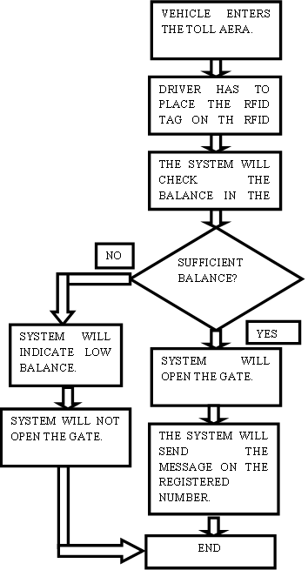

**6.1 Scope**

As we have used a short range RFID reader, the driver has to take the tag near the reader. But if we use a high range RFID reader, we can stick the tag to the wind shield and the reader will automatically detect the tag from a long range. This way no car has to stop on the toll booth. This system is called as Electronic Toll Collection System.

Electronic toll collection (ETC) aims to eliminate the delay on toll roads by collecting tolls electronically. ETC determines whether the cars passing are enrolled in the program, alerts enforcers for those that are not, and electronically debits the accounts of registered car owners without requiring them to stop.

In 1959, Nobel Economics Prize winner William Vickrey was the first to propose a system of electronic tolling for the Washington Metropolitan Area. He proposed that each car would be equipped with a transponder. “The transponder’s personalised signal would be picked up when the car passed through an intersection, and then relayed to a central computer which would calculate the charge according to the intersection and the time of day and add it to the car’s bill” Electronic toll collection has facilitated the concession to the private sector of the construction and operation of urban freeways, as well as made feasible the improvement and the practical implementation of road congestion pricing schemes in a limited number of urban areas to restrict auto travel in the most congested areas.

**Acknowledgement**

Completion of our project is a task, which would not have been accomplished without appreciation and help from our guide and other members. Gratitude is one of the hardest emotions to express. We o sincerely wish to express. This deep emotion to our project guide M.S.Kulkarni mam.

Prof .Kulkarni whose permission to start on this particular project gave us ample amount of encouragement and whose guidance and co-operation cultivated our ideas into action.

She acted as a constant source of inspiration and enlightened us to attain heights in our project. We also thank her for providing us with necessary theoretical and practical information regarding our project.

We express our sincere thanks to our Head of Department Prof. A.Bhakare whose mere presence and few words of encouragement use to feel us with enough energy to overcome all obstacles and motivate to achieve the goal.

We consider this as a golden opportunity to extend our deepest feelings of indebtedness to all our respected teaching staff for having inspired us to work in the right spirit of creativity and logic. We specially thank Prof. M Joshi for supporting without which it would have been a difficult task. Last, but not the least we would like to thank our respected Principle Prof. R. Kale for constant encourage and support. Also we would like to thank our friends who have helped us, directly or indirectly in our endeavours.

With regards to all,

Yogesh Shaligram

Yash Sathe

Swapnil Shinde

Shubham Sabale

3.1 Circuit Diagram-

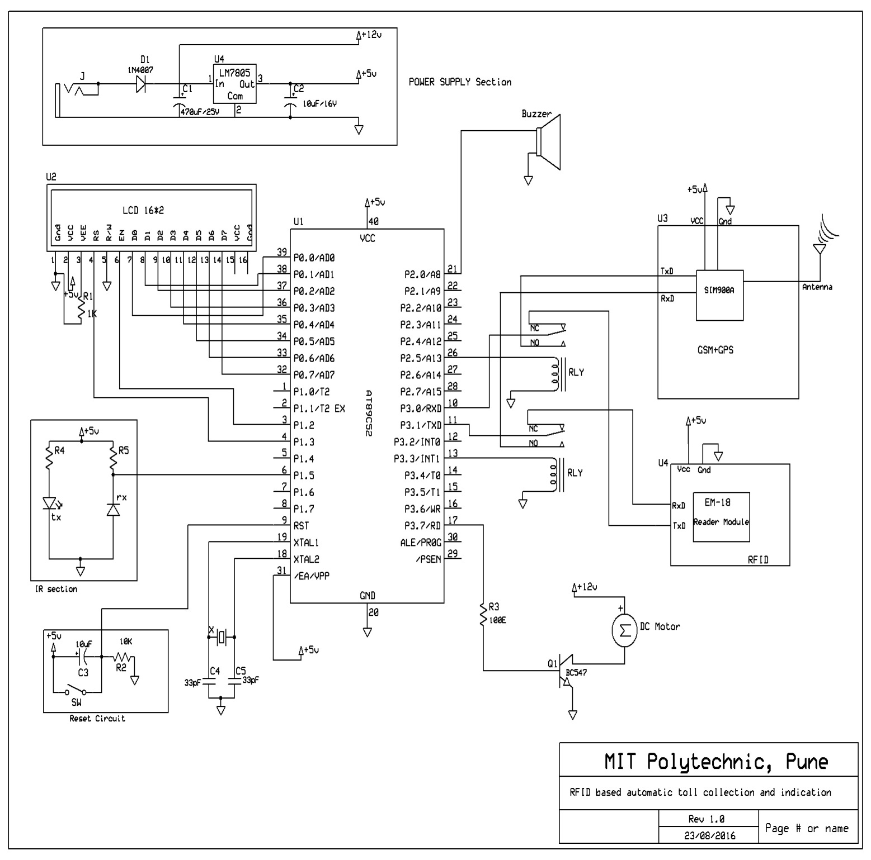

**Fig. Circuit Diagram**

3.2 Hardware Description-

1. Microcontroller Interface-

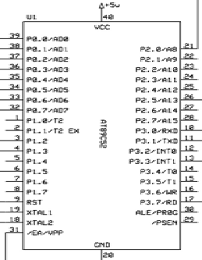

**Fig. Interface Diagram**

The AT89C51 is a low-power, high-performance CMOS 8-bit microcomputer with 4K bytes of Flash programmable and erasable read only memory (PEROM). The device is manufactured using Atmel’s high-density non-volatile memory technology and is compatible with the industry-standard MCS-51 instruction set and pin out. The on-chip Flash allows the program memory to be reprogrammed in-system or by a conventional non-volatile memory programmer. By combining a versatile 8-bit CPU with Flash on a monolithic chip, the Atmel AT89C51 is a powerful microcomputer which provides a highly-flexible and cost-effective solution to many embedded control applications.

2. Power Supply-

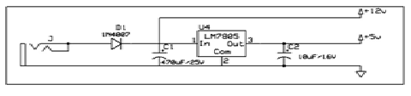

Fig. Power Supply Circuit Diagram

As we have used a 12V Stepper motor, we have to design a power supply which can provide 12V as well as 5V for microcontroller and other devices.

So, we can use LM7805 IC. This gives two different output voltages*.*

3. RFID Reader-

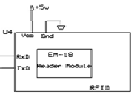

Fig. RFID Reader Modulator

A radio frequency identification reader (RFID reader) is a device used to gather information from an RFID tag, which is used to track individual objects. Radio waves are used to transfer data from the tag to a reader.

RFID Reader is placed in front of the tool booth so that the driver can place the RFID Tag on the Reader.

The range of this reader is few centimetres. There are two types of RFID Tags such as Active and Passive Tags. In passive RFID tag, as it does not contains the supply of its own, when the tag comes in contact with the reader, the reader provides the supply to the tag so as to energise it. When supply is provided, coil in the tag gets charged and the reader detects the unique code of the tag.

In the active RFID tags, as it has its own power supply, the coil in the Tag is energised as a default. So the reader need not supply the power. This type of tags can be used for long distance detection.

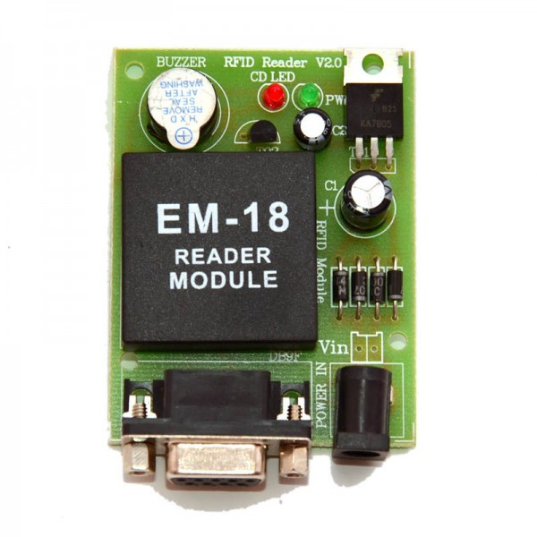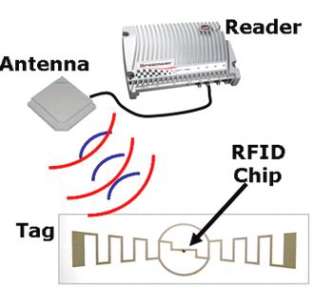

4. GSM Module-

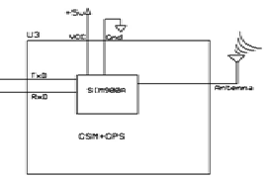

Fig. GSM Module

A GSM modem is a specialized type of modem which accept a sim card, and operates over a subscription to a mobile operator, just like a mobile phone. From the mobile operator prespective, a gsm modem looks just like a mobile phone.

When a GSM modem is connected to a computer, this allows the computer to use the GSM modem to communicate over the mobile network. While the GSM modules are most frequently used to provide mobile internet connectivity, many of t modem can be hem can also be used for sending and receiving SMS and MMS messages.

A GSM modem can be a dedicated modem device with a serial, USB or Bluetooth connection, or it can be a mobile phone that provides GSM modem capabilities.

GSM modems can be a quick and effective way to get started with SMS, because a special subscription to an SMS service provider is not required. In most parts of the world, GSM modems are a cost effective solution for receiving SMS messages, because the sender is paying for the message delivery.

5. IR Sensor-

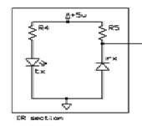

Fig. IR Sensor

An IR sensor consists of an IR LED and an IR Photodiode; together they are called as Photo–Coupler or Opto–Coupler. As said before, the Infrared Obstacle Sensor has built in IR transmitter and IR receiver. Infrared Transmitter is a light emitting diode (LED) which emits infrared radiations. Hence, they are called IR LED’s. Even though an IR LED looks like a normal LED, the radiation emitted by it is invisible to the human eye. Infrared receivers are also called as infrared sensors as they detect the radiation from an IR transmitter. IR receivers come in the form of photodiodes and phototransistors. Infrared Photodiodes are different from normal photo diodes as they detect only infrared radiation. When the IR transmitter emits radiation, it reaches the object and some of the radiation reflects back to the IR receiver. Based on the intensity of the reception by the IR receiver, the output of the sensor is defined.

6. LCD-

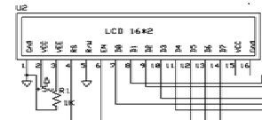

Fig. LCD

A 16x2 LCD means it can display 16 characters per line and there are 2 such lines. In this LCD each character is displayed in 5x7 pixel matrix. This LCD has two registers, namely, Command and Data.

The command register stores the command instructions given to the LCD. A command is an instruction given to LCD to do a predefined task like initializing it, clearing its screen, setting the cursor position, controlling display etc. The data register stores the data to be displayed on the LCD. The data is the ASCII value of the character to be displayed on the LCD.

7. DC Motor-

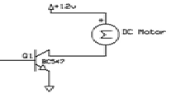

Fig. DC Motor

A DC motor is any of a class of rotary electrical machines that converts direct current electrical power into mechanical power. The most common types rely on the forces produced by magnetic fields. Nearly all types of DC motors have some internal mechanism, either electromechanical or electronic; to periodically change the direction of current flow in part of the motor.

A coil of wire with a current running through it generates an electromagnetic field aligned with the centre of the coil. The direction and magnitude of the magnetic field produced by the coil can be changed with the direction and magnitude of the current flowing through it.

8. Buzzer-

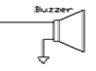

Fig. Buzzer

9. Reset Circuit-

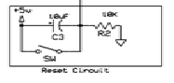

Fig. Reset Circuit

**PCB Design & Explanation**

Layout Planning-

For placing the component in the layout all the information about circuit needed for the artwork preparation. The layout should prepare from the component size. Layout planning means planning the placing of the components and input output connection for a given circuit.

PCB means printed circuit board PCB is one of the most important elements in any electronic system. They accomplish the interconnection between the component mounted on them in particular manner PCB consist of conductive circuit pattern which is applied to one or both sided of an insulating base copper is most widely used for conducting material. Aluminium, nickel, silver, brass is used for same special application. The thickness of conducting material depends upon the current carrying capacity of circuit. Thus a thicker conductor layer will have mare current carrying capacity once the PCB is manufactured the current carrying capacity depends on which of conductor track.

Types of PCB

1. Single Sided PCB-

This type of PCB consists of a natural coil of a copper on only one side of the base material. This type of PCB frequently used when the manufacturing cost has to be kept at minimum.

1. Double Sided PCB-

Double sided PCB is used when there is more number of jumpers. The type of PCB has copper fail on both side of base material. The double-sided PCB’s are used when insulation of PCB is very complicated i.e. if jumpers are more in number and when it is difficult to fabricants the PCB ON a single sided PCB.

**The various steps involved in PCB.**

Painting and Etching-

To paint and etching of transferring artwork of given circuit, the apparatus required are paint glass tray etching solution (FECL 3) clad.

Painting: Cu tracks are filled with paint after and completion of artwork on Cu clad etching is the process of remaining extra unwanted copper from the surface of Cu warm water is taken in a glass tray and two or three spoons full of perica chloride are added to it in the copper clad containing the circuit designed is emerged in the tray having the ferric chloride solution. After some time the exposed copper gets etched. The copper clad is now taken of the solution and washed with one dried paint on the copper clad can be removed with kerosene or petrol.

Drilling-

Is the process of making opinion at the proper place where the mounting of component are required to achieve by using different drill bits or different dimension i.e. 0.5mm, 1mm, 15mm drilling is done either by using hand drill or M/L drill.

This is the process of placement of component at proper places. The components are mounted on the opposite side if cu track by checking polarities i.e. +ve or –ve. Before mounting the components the lead so component should be staggered pliers and cleaned with blade.

For Mounting Resister-

First the value of resistance is checked by using mom of cooler code then the leads of resistors bending device. The body of resister should touch the PCB surface.

For Mounting Capacitor-

First the capacitance value of capacitor is check it polarities are given then. It is mounted in such a manner that the polarities be correct. Then leads are inserted in the hole and bend properly. If the length of lead is more than it should be cut for mounting resistor. The leads of transistor are mounted into the hole for mounting transistor. Each must have insulating slave because there is less space between the terminals mounting of diode. First the diode is tested, then mounted by Taking anode and cathode in consideration.

Soldering technique-

To active the moderate joint of the component with PCB the soldering is used. There are two methods of soldering

* IRON SOLDERING
* MASH SOLDERING

Procedure of soldering-

The part to be joint must be cleaned and fluxed. The metal parts, which are to be joined, and the solder metal are heated with the help of soldering iron. The angle made by soldering iron with the metal. Surface should be approximately, equals to 450. As the melting point of the solder metal is us so it melts first. Then this melted putting of the solder material if forms permanent joints.

The protection of PCB from atmospheric corrosion-

Cu tracks of PCB can be protected by means of lacquer coating. Sometimes PCB can also be protected by using enamel varnish or tin or gold platting done on Copper tracks.

Software specifications-

Some of the software use in this system are as follows,

1. Express PCB-

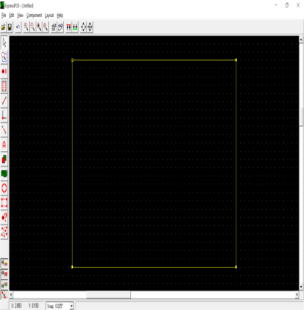

Express PCB is used to design the PCB Layout. We just have to select the component required and place on the work place. When your circuit is ready, you have to get a printout of this circuit and with the help of the print; you can print the circuit on the PCB easily. Don’t forget we have to create the circuit in opposite direction. So that it gets printed on PCB correctly.

1. Express SCH-

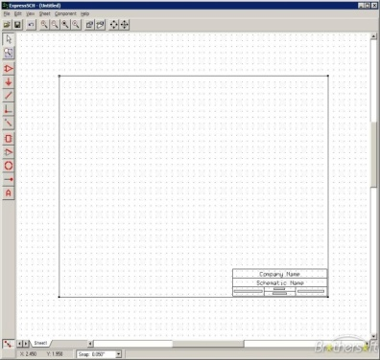

Express SCH is used to design the circuit diagram. Because of Express SCH we can easily design a circuit diagram. We just have to select the component required and place wherever we want. Then connect the placed component. In Express SCH we can also name the components added in the circuit diagram. We can also write the company name, Designer’s name, Date, etc.

1. Keil uversion 3-

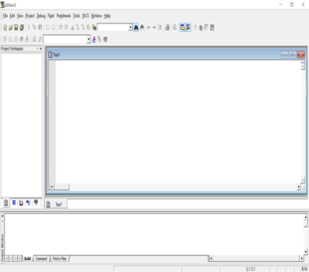

Keil software is for the programming of microcontroller. The main programming of the system is made in Keil software. In this, the commands which have to be given to the microcontroller are written in this software. This software also has its own compiler which makes error finding more easy.

1. MATLAB 7.10.0 -

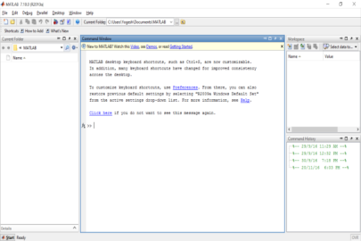

We have interfaced microcontroller to PC.

MATLAB software is used for designing the format of the PC screen in which the information is been displayed.

As we have an added function that if a car driver pays the toll, his information will appear on the server computer.

Information such as vehicle owner’s name, vehicle registration number, vehicle type(e.g.- Car, Truck, Bus, etc.), Time of paying toll, etc.

Circuit photographs

Source Code

* Open the Keil Version Software
* The following figure will appear

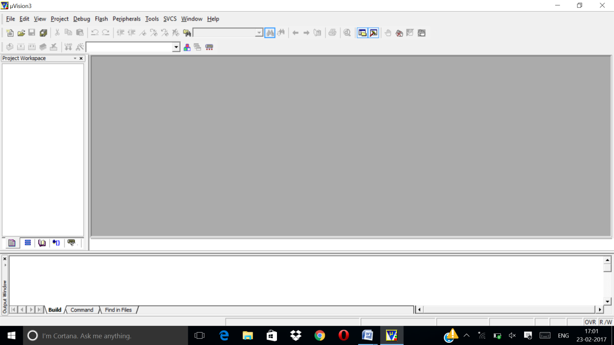

* Click on the Project Menu from the Title Bar
* Then Click on New Project
* Save th Project by typing suitable project name with no extension in your own folder sited in either C:\ or D:\
* Then Click on save button
* Select the component for your project i.e. Atmel..
* Click on the +Symbol beside of Atmel

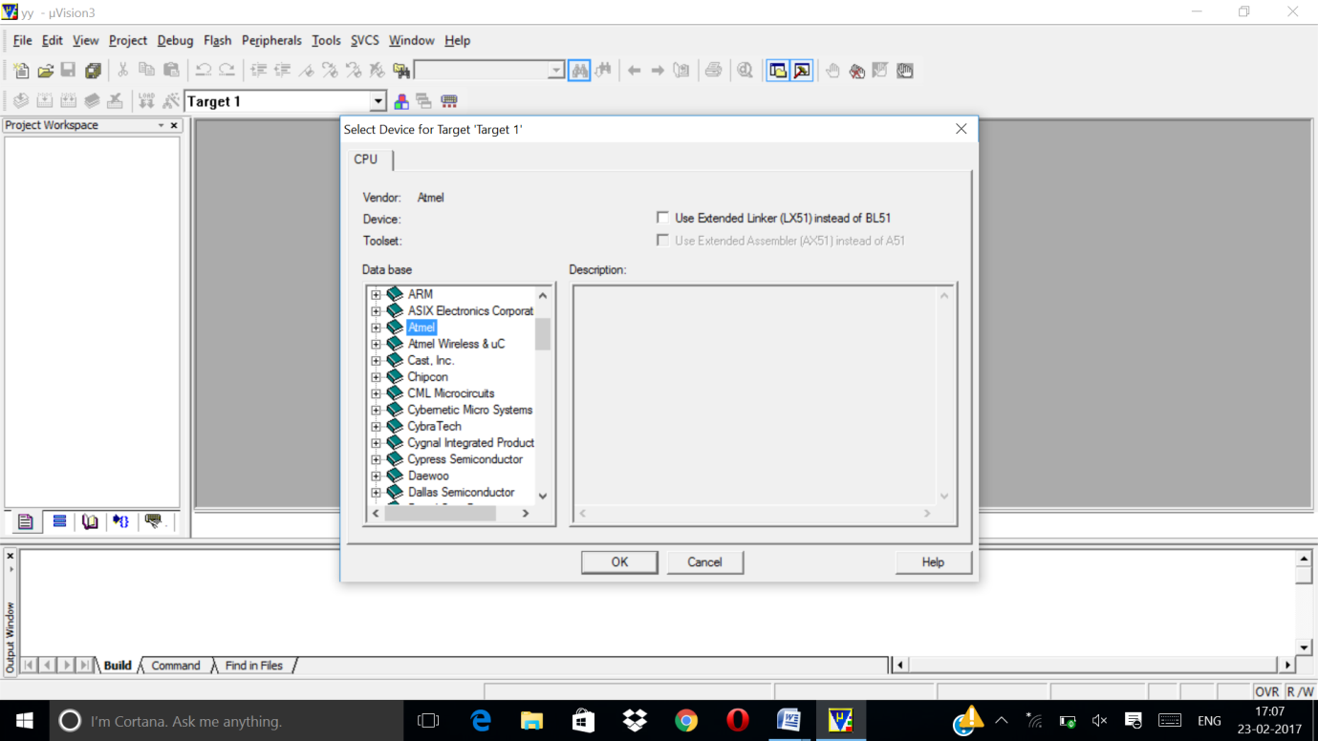

* Select AT89C51 as shown below

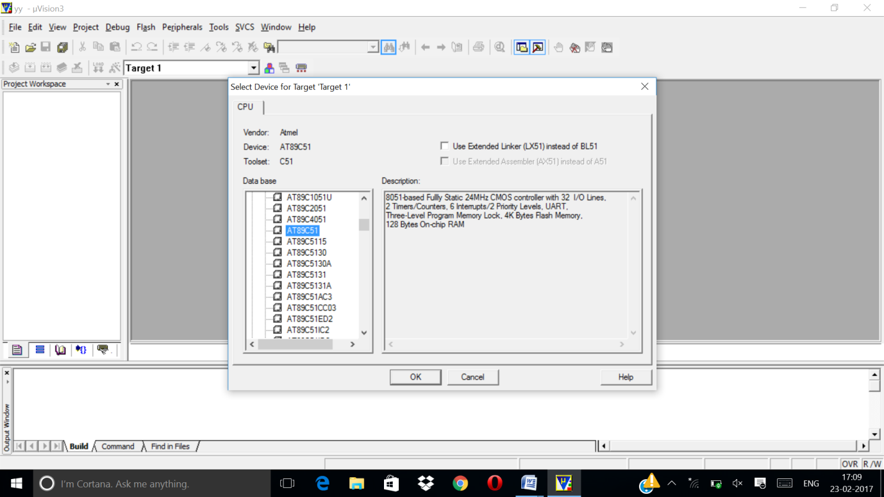

* Then click on “OK”
* Then Click either YES or NO….mostly “NO”
* Now your project is ready to use
* Now double click on the Target1, you would get another option “Source group 1” as shown below
* Click on the file option from menu bar and select “new”
* The next screen will be as shown in next page and just maximize it by double clicking on its blue boarder

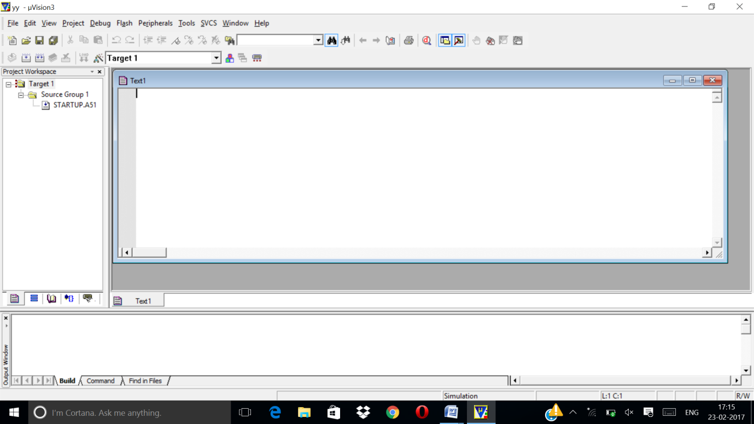

* Now start writing program in either in “C”
* For a program written in Assembly, then save it with extension “.asm” and for “C” based program save it with extension “.C”
* Now right clicl on Source group 1 and click on “Add files to Group Source”

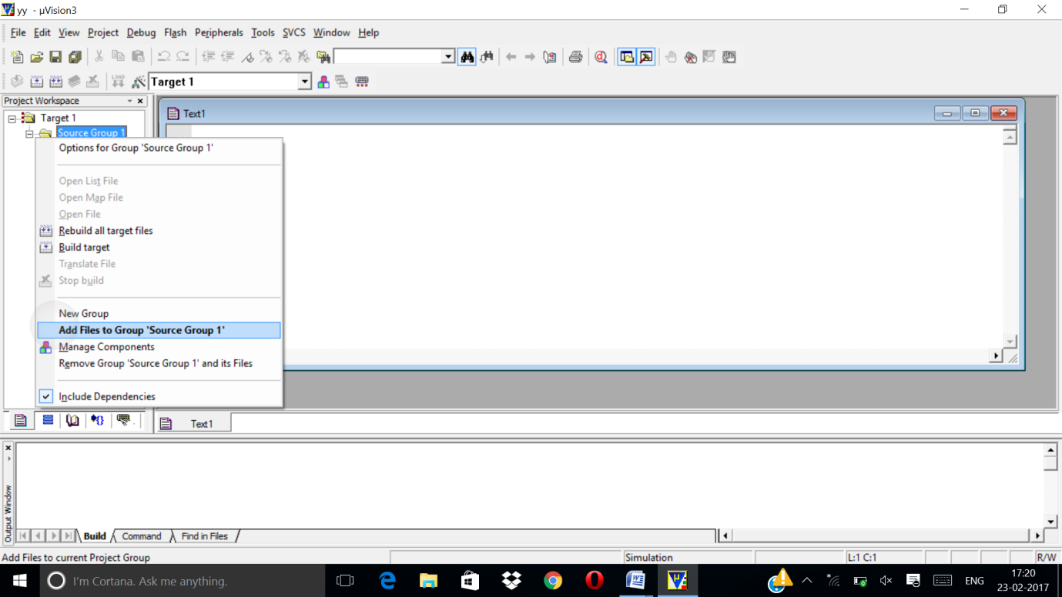

* Now you will get another window, on which by default “C” files will appear.
* Now select as per your file extension given while saving the file
* Click on the option “Add”
* Now Press function key F7 to compile. If error exists, it will be displayed
* If the file contains on error, then press ctrl+F5 simultaneously
* Then click “OK”
* Now click on the Peripherals from menu bar, and check your required port as shown in figure bellow
* Drag the port aside and click in the program file